Mater Dolorosa Catholic Church
First Communion and Confirmation Students Must bring a copy of their Baptism Certificate for Registration.
8128 Plum Street
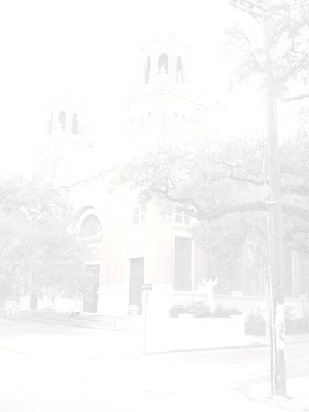
New Orleans, LA 70118
(504) 866-3669 Fax: (504) 866-2349

PSR (Parish School of Religion) REGISTRATION FORM
School Year 2024- 2025

Student’s Name ____________________________________________________________________________________
Last First Middle
Child resides with ________________________________ Male _____ Female _____

Child’s date of birth: ______________________ Place of Birth: ____________________________________ Month Day Year

Baptism Church: _____________________________________ Date of Baptism ________________________________ Name of Church Month Day Year

Address of Baptism Church: ____________________________________________________________________

Church of First Communion: ____________________________________________________________________

Student’s E-Mail: ____________________________________________ Cell Phone: ______________________

Grade:________ School: ______________________________________________________________________

Birth Father’s Name: ________________________________________Religion_________________________________ ___________________________________________________________________________________
Address: _________________________________________________________Phone:___________________________

Mother’s Maiden Name:_____________________________________________Religion:_________________________

Address: __________________________________________________________Phone:___________________________

Cell phone: Father _________________________________ Mother:__________________________________________

Home e-mail address: ________________________________________________________________________________

Please list any allergies: ______________________________________________________________________________

Are you a registered parishioner of (select one)

______ Mater Dolorosa or Other: _____________________________________________________________

Emergency contact: _________________________________________________________________________________
Full Name____

Relation: ______________________________________ Phone:_____________________________________________

I recognize that the education of my child in the Catholic Faith is a serious obligation. I agree to support the efforts of the teachers of Mater Dolorosa PSR Program in this task. I will assist my child with home study assignments and will attend MASS with my child. I will also acquaint myself with my child’s progress and what my child is being taught.

Submit completed form and $30.00 registration fee or $40.00 for children preparing for First Communion or Confirmation, payable to Mater Dolorosa Church.

If you have any questions regarding registration or PSR Program, ________________________________________________
please contact the office at 866-3669. Parent’s Signature

Payment enclosed: $_______________ Check Cash Date: _____________________________

Photo Release

I _____________________, hereby give Mater Dolorosa Church permission to use my child/children’s photograph in all its publications. I understand and agree that the photographs will become property of Mater Dolorosa and will not be returned.
I acknowledge that since my participation with Mater Dolorosa is voluntary, I will receive no monetary compensation.
Mater Dolorosa has my permission to edit, alter, copy, exhibit and publish this photo in their programs or publications (Clarion Herald) and I waive the right to inspect or approve the finished product. I also waive the right to royalties or other compensation arising or related to the use of the photographs, videos, etc.
I release Mater Dolorosa from all claims and demands which I, or any other person acting on my behalf.
I am at least 18 years of age, have read any fully understand the contents of this release.

Participants name: ___________________________________________
Signature: __________________________________________________
If under 18 years of age, guardian’s signature: _______________________________
Date: __________________________________________

Mater Dolorosa Church
8128 Plum Street
New Orleans – LA – 70118

Safe Environment Class

I ________________________, hereby authorize Mater
Dolorosa Church permission to teach my child
______________________________, safe environment.
I understand that I may attend the class with my child and
that all classes will be age appropriate.

Dated: _______________
Signature: ____________________ Date: ________

Please Print your name: ______________________________

