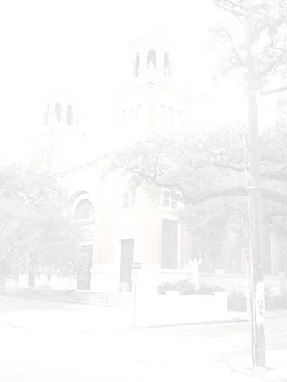
Mater Dolorosa Church

8128 Plum Street
New Orleans, Louisiana 70118
Telephone: (504) 866-3669 Fax: (504) 866-2349

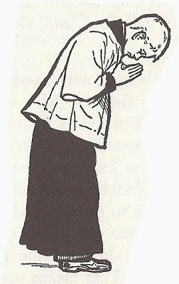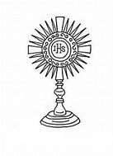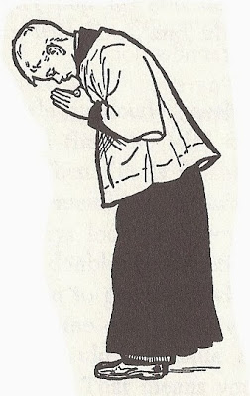

2024-2025 Form

I, __________________________________ ____________________________

The parent of _____________________________ ________________________

Give my son/daughter permission to join the altar server program of Mater Dolorosa.

Signature __________________________________________

Phone number: __________________Cell phone number: __________________

Mother: ________________________Father: _____________________________

Email address: _____________________________________________________

Physical address: ___________________________________________________



Photo Release

I _____________________, hereby give Mater Dolorosa Church permission to use my child/children’s photograph in all its publications. I understand and agree that the photographs will become property of Mater Dolorosa and will not be returned.
I acknowledge that since my participation with Mater Dolorosa is voluntary, I will receive no monetary compensation.
Mater Dolorosa has my permission to edit, alter, copy, exhibit and publish this photo in their programs or publications (Clarion Herald) and I waive the right to inspect or approve the finished product. I also waive the right to royalties or other compensation arising or related to the use of the photographs, videos, etc.
I release Mater Dolorosa from all claims and demands which I, or any other person acting on my behalf.
I am at least 18 years of age, have read any fully understand the contents of this release.

Participants name: ___________________________________________
Signature: __________________________________________________
If under 18 years of age, guardian’s signature: _______________________________
Date: __________________________________________

